**PART B**

**Micro- Project Report**

**Group No.: - Course:-CO4I**

**Title of Project: -Employee Management System Subject:-GAD**

* 1. **Rationale:-**

1. An employee management system consists of crucial work-related and important personal information about an employee.
2. In a nutshell, it is an online inventory of all employees of an organization.
3. Employees are the strength of any organization, and it is more so in case of a growing business.
4. It is crucial to handle this aspect of your business well.
5. A good employee management system can actually make a world of difference to an organization, especially true in case of start ups and small businesses, where the focus should be on growing the business more than anything else.

**2.0 Aim of Micro Project:-**

1. To have ideas and essential information on the project and also the importance of vb.net.
2. Employee Management System makes everyday employee tasks more efficient. This means more work can be done in less time.
3. Consequently, this decreases operational costs.
4. This also minimizes paperwork and manual tasks.

**3.0 Course Outcomes Integrated:-**

1. Use visual studio IDE to design application.
2. Develop GUI application using form controls and its events.
3. Apply object oriented concepts in GUI application.
4. Use data access controls to store data in database and retrieve it.
5. Use data binding in GUI application.
6. **Litrature review**
7. To tell in short, as the name itself tells that employee management system manages all the details of each and every employee in an organization.
8. Employee Management solutions are designed to better measure, analyse and manage employees’ working hours and deploy human resources more effectively.
9. Employee Management System is open to admins, HR team, Managers, and regular employees. Among all users, only the admins have all privileges to access all the information of Employee Management Software.
10. So the admins will insert, update, remove the employees, departments, generate reports and whereas other users will have limited roles. Once the user’s login they can perform few tasks specific to their role.
11. An employee management system is designed to streamline HR and other business department duties. Most key operations — from employee timesheets and time off requests to staff geo-location during work hours — can be handled by a system like this.
12. The key is to find a system that not only works well for your team, but one that also saves you time, headaches, and money. Any employee management system should cover essential HR features.
13. One of the most common ways of managing teams, especially remote workers, is regular reporting via email. However, this method is cumbersome and messy.
14. The key to optimizing your team’s performance is taking the time-consuming admin tasks out of the picture, so you can all focus on accomplishing more.
15. This article will outline the benefits of management systems, and the best apps and tools you can use to improve your team’s efficiency.
16. A web-based employee management system helps you be more efficient with your time, and reduces the time your team spends on repetitive, administrative tasks.
17. Having an employee management system in place means you can access all the essential information about your team, projects, and clients from a single dashboard.
18. This centralized insight is what every good employee management system should offer. Plus, you should also look for a system that provides:
    * 1. Optimized workload and streamlined admin tasks
      2. Data security
      3. Increased employee engagement
    1. **Actual Methodology followed:**
    2. stepwise description:
    3. We collected information from various sources available.
    4. We designed diagrams for the following.
    5. Thus execution of project was made.

**6.0 Actual Resources Used:-**

|  |  |  |  |  |
| --- | --- | --- | --- | --- |
| **Sr.no** | **Name of resources** | **Specifications** | **Qty** | **Remarks** |
| 1 | Operating system | Windows 10 | 01 |  |
| 2 | Visual Studio | 2017 | 01 |  |
| 3 | Microsoft word | 2019 | 01 |  |

**7.0 Outputs of the Micro-Projects:-**

FORM 1

Public Class Form1

Private Sub Button1_Click(sender As Object, e As EventArgs) Handles Button1.Click

Form2.Show()

End Sub

End Class

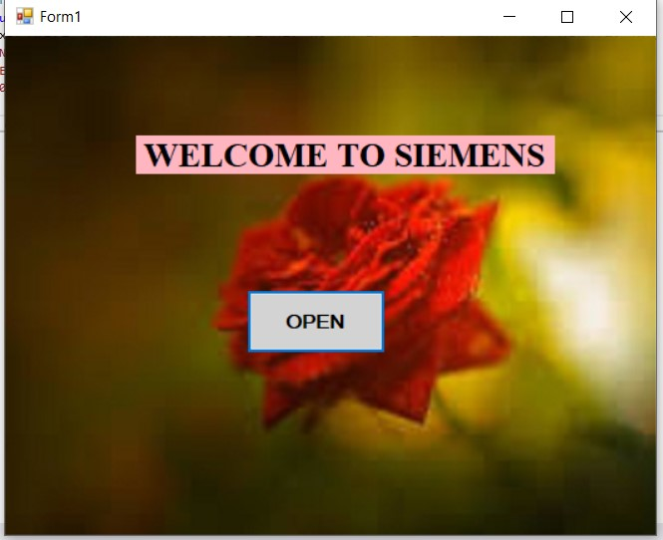

FORM 2

Public Class Form2

Private Sub Button1_Click(sender As Object, e As EventArgs) Handles Button1.Click

If TextBox1.Text = "Admin" And TextBox2.Text = "123" Then

Form3.Show()

Else

MsgBox("Enter correct username and password")

End If

End Sub

End Class

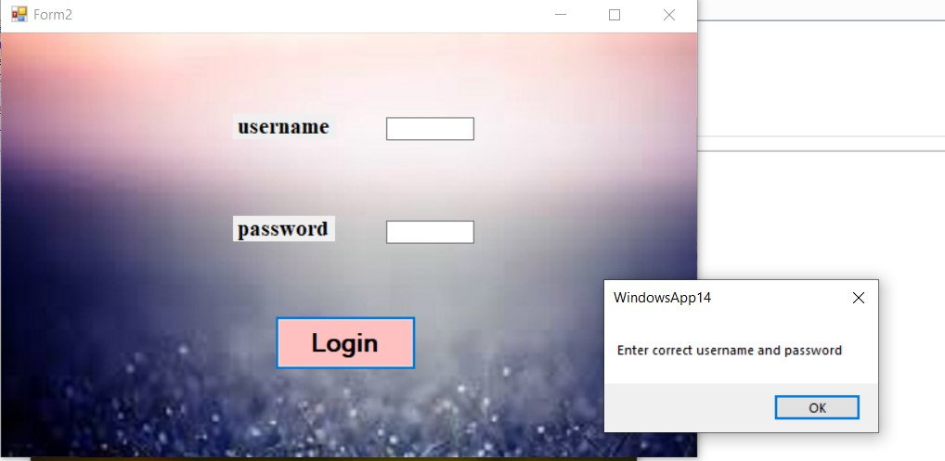

FORM 3

Public Class Form3

Private Sub Button1_Click(sender As Object, e As EventArgs) Handles Button1.Click

Form4.Show()

End Sub

Private Sub Button2_Click(sender As Object, e As EventArgs) Handles Button2.Click

Form5.Show()

End Sub

Private Sub Button3_Click(sender As Object, e As EventArgs) Handles Button3.Click

Form6.Show()

End Sub

Private Sub Button4_Click(sender As Object, e As EventArgs) Handles Button4.Click

Form7.Show()

End Sub

Private Sub Button5_Click(sender As Object, e As EventArgs) Handles Button5.Click

Form8.Show()

End Sub

End Class

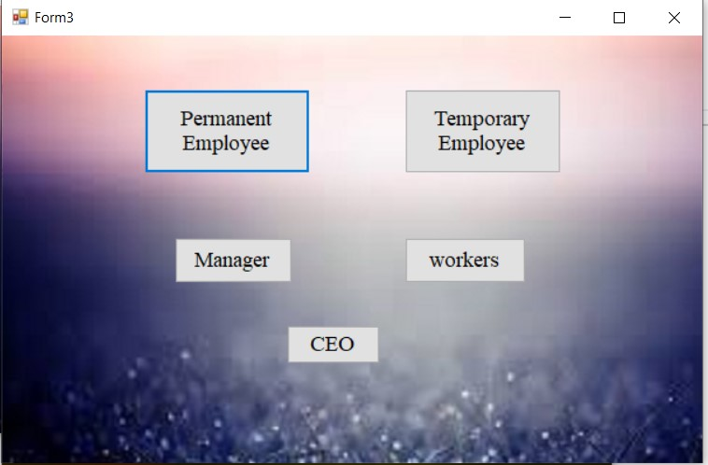

FORM 4

Private Sub Button1_Click(sender As Object, e As EventArgs) Handles Button1.Click

MsgBox(" NAME= Bharat Chougale

DATE OF JOINING= 12\04\2018

JOB TITLE = HR

SALARY = 50,000")

End Sub

Private Sub Button2_Click(sender As Object, e As EventArgs) Handles Button2.Click

MsgBox(" NAME= Vishal Jadhav

DATE OF JOINING= 13\07\2018

JOB TITLE = Tech

SALARY = 40,000")

End Sub

Private Sub Button3_Click(sender As Object, e As EventArgs) Handles Button3.Click

MsgBox(" NAME= Deepak Dhere

DATE OF JOINING= 15\06\2017

JOB TITLE = Tech

SALARY = 40,000")

End Sub

Private Sub Button4_Click(sender As Object, e As EventArgs) Handles Button4.Click

MsgBox(" NAME= Sandeep Chougale

DATE OF JOINING= 11\02\2019

JOB TITLE = Designer

SALARY = 35,000")

End Sub

Private Sub Button5_Click(sender As Object, e As EventArgs) Handles Button5.Click

MsgBox(" NAME= Tanaji Hujare

DATE OF JOINING= 28\11\2017

JOB TITLE = Office Clerk

SALARY = 30,000")

End Sub

Private Sub Button6_Click(sender As Object, e As EventArgs) Handles Button6.Click

Form3.Show()

End Sub

End Class

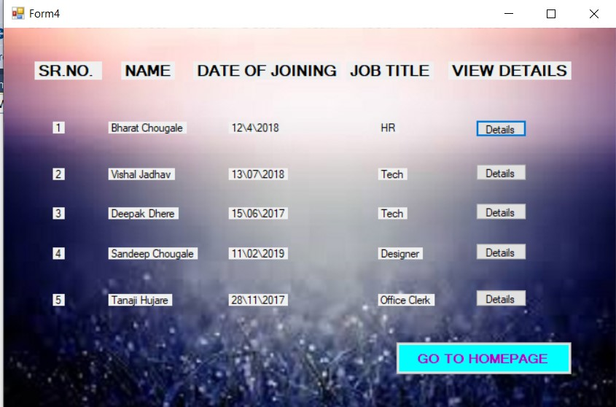

FORM 5

Private Sub Button2_Click(sender As Object, e As EventArgs) Handles Button2.Click

MsgBox(" NAME= Rama Agam

DATE OF JOINING= 09\09\2018

JOB TITLE = Security

SALARY = 10,000")

End Sub

Private Sub Button3_Click(sender As Object, e As EventArgs) Handles Button3.Click

MsgBox(" NAME= Sandeep Joshi

DATE OF JOINING= 09\09\2018

JOB TITLE = House Keeping

SALARY = 8,000")

End Sub

Private Sub Button4_Click(sender As Object, e As EventArgs) Handles Button4.Click

MsgBox(" NAME= Sandip Gosavi

DATE OF JOINING= 27\02\2019

JOB TITLE = Security Incharge

SALARY = 10,000")

End Sub

Private Sub Button5_Click(sender As Object, e As EventArgs) Handles Button5.Click

MsgBox(" NAME= Hemant Paradkar

DATE OF JOINING= 21\12\2019

JOB TITLE = Office Clerk

SALARY = 10,000")

End Sub

Private Sub Button1_Click(sender As Object, e As EventArgs) Handles Button1.Click

MsgBox(" NAME= Adinath Chougale

DATE OF JOINING= 11\05\2018

JOB TITLE = Telephone Operator

SALARY = 15,000")

End Sub

Private Sub Button6_Click(sender As Object, e As EventArgs) Handles Button6.Click

Form3.Show()

End Sub

End Class

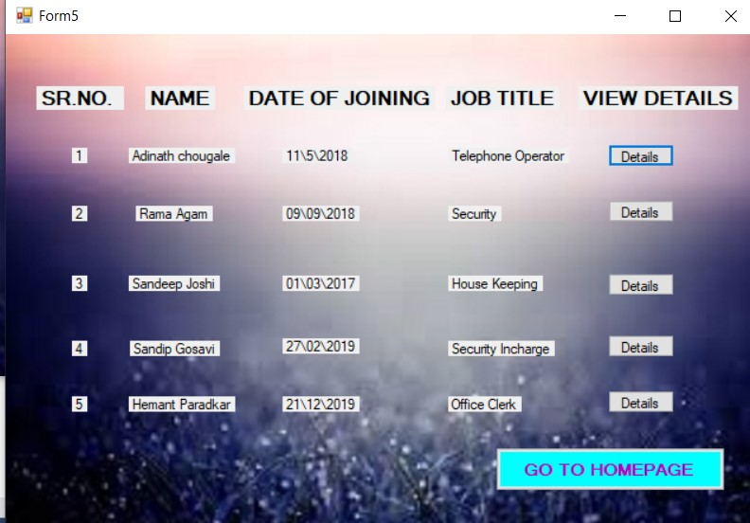

FORM 6

Private Sub Button1_Click(sender As Object, e As EventArgs) Handles Button1.Click

MsgBox(" NAME= Kalpesh Sawant

DATE OF JOINING= 12\07\2018

JOB TITLE = Manager

SALARY = 50,000")

End Sub

Private Sub Button2_Click(sender As Object, e As EventArgs) Handles Button2.Click

MsgBox(" NAME= Chinmay Varhadi

DATE OF JOINING= 01\06\2018

JOB TITLE = Manager

SALARY = 50,000")

End Sub

Private Sub Button6_Click(sender As Object, e As EventArgs) Handles Button6.Click

Form3.Show()

End Sub

End Class

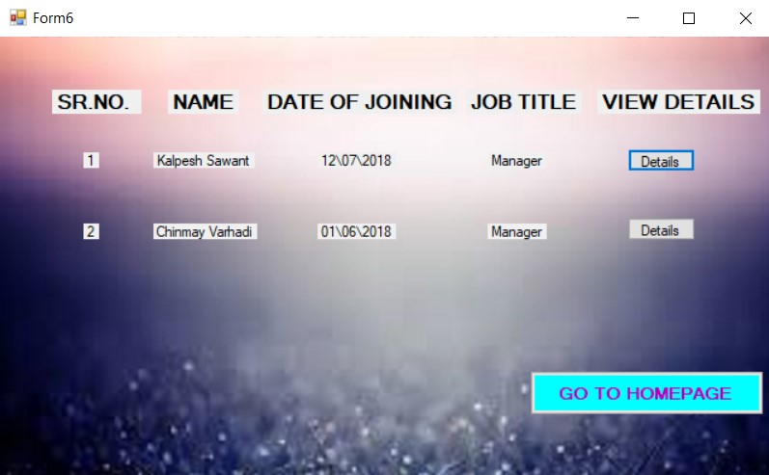

FORM 7

Public Class Form7

Private Sub Button1_Click(sender As Object, e As EventArgs) Handles Button1.Click

MsgBox(" NAME= Durvesh Patil

DATE OF JOINING= 14\08\2018

JOB TITLE = Accountant

SALARY = 30,000")

End Sub

Private Sub Button2_Click(sender As Object, e As EventArgs) Handles Button2.Click

MsgBox(" NAME= Rushi Gaikwad

DATE OF JOINING= 13\07\2018

JOB TITLE = Sells Manager

SALARY = 20,000")

End Sub

Private Sub Button3_Click(sender As Object, e As EventArgs) Handles Button3.Click

MsgBox(" NAME= Kaivalya Gosavi

DATE OF JOINING= 15\06\2017

JOB TITLE = Contact Receiver

SALARY = 20,000")

End Sub

Private Sub Button4_Click(sender As Object, e As EventArgs) Handles Button4.Click

MsgBox(" NAME= Vinayak Godse

DATE OF JOINING= 23\10\2017

JOB TITLE = Designer

SALARY = 10,000")

End Sub

Private Sub Button5_Click(sender As Object, e As EventArgs) Handles Button5.Click

MsgBox(" NAME= Tushar Hujare

DATE OF JOINING= 22\09\2018

JOB TITLE = Sells Manager

SALARY = 15,000")

End Sub

Private Sub Button6_Click(sender As Object, e As EventArgs) Handles Button6.Click

Form3.Show()

End Sub

End Class

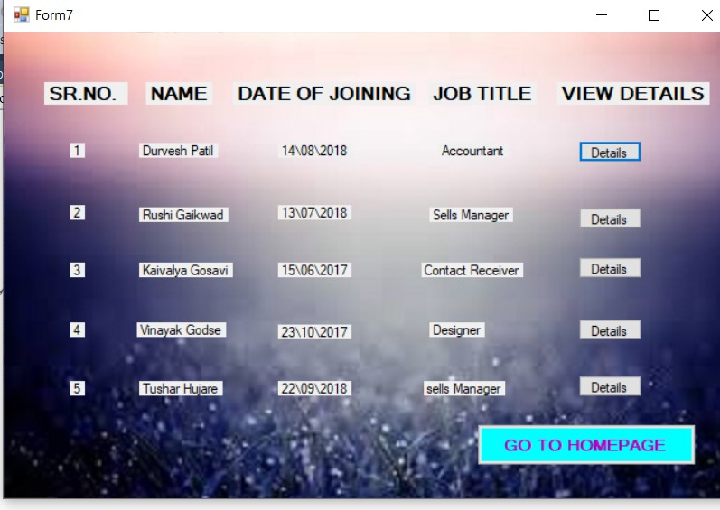

FORM 8

Public Class Form8

Private Sub Button1_Click(sender As Object, e As EventArgs) Handles Button1.Click

MsgBox(" NAME= Anish Jadhav

DATE OF JOINING= 28\03\2018

JOB TITLE = CEO

SALARY = 80,000")

End Sub

Private Sub Button6_Click(sender As Object, e As EventArgs) Handles Button6.Click

Form3.Show()

End Sub

End Class

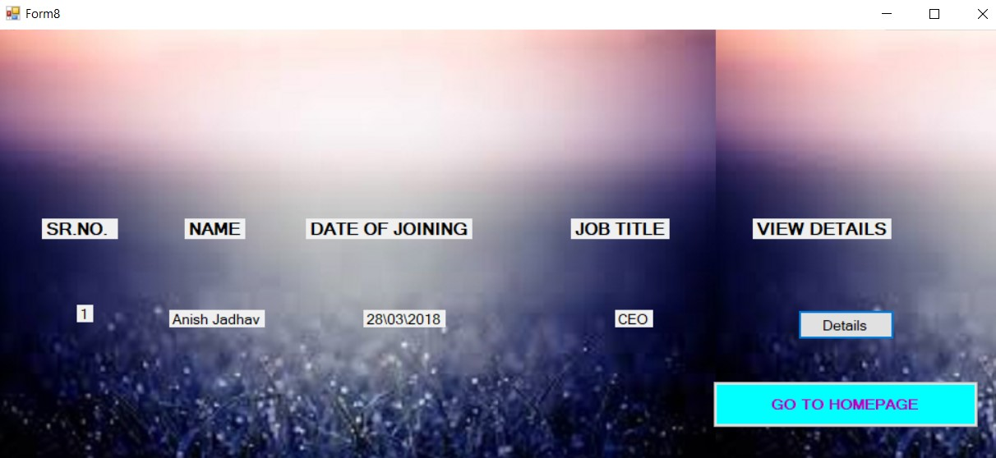

**8.0 Skill developed/ Learning out of this Micro-Project:-**

1. We have learn about vb.net programming.
2. We have learn about how to use programming techniques to develop .net based applications.

**8.1. Conclusion:-**

1. This project has a real time applications this project is used to manage all the information about employee name, age, salary, login, leaves.
2. This project is especially useful for employee for getting all required things for their department.